Title : 2.4-GHz CMOS RF Front-End Receiving Circuits
Subject area : Communication Analog Circuits
Authors : Yu-Shun Huang, Chia-Shin Wu and Shen-Iuan Liu

劉深淵
國立台灣大學電機工程研究所教授
Email : lsi@cc.ee.ntu.edu.tw
電話：(02)23635251轉239 傳真：(02)23671909
黃以舜
國立台灣大學電機工程研究所碩士班研究生
Email : r87004@ee.ntu.edu.tw
電話：(02)23635251轉328 傳真：(02)23638247
吳家欣
國立台灣大學電機工程研究所碩士班研究生
Email : r88066@ee.ntu.edu.tw
電話：(02)23635251轉328 傳真：(02)23638247

2.4-GHz CMOS RF Front-End Receiving Circuits

Yu-Shun Huang, Chia-Shin Wu and Shen-Iuan Liu
Department of Electrical Engineering
National Taiwan University
Taipei, Taiwan 10664, R.O.C.

Abstract—In this paper, 2.4-GHz RF Front-end receiving circuits using standard 0.35-μm CMOS process are presented. A double-stage LNA provides 12dB gain and 5dB NF, while consuming 66mW from a 3.3V supply. The 2.4GHz-to-280MHz down-conversion mixer exhibits single-ended con-version of –2dB and IIP3 of –1.7dBm. The mixer consumes 20mW from a 3.3V supply. The double-stage LNA combined with the mixer shows +9dB single-ended conversion gain and –6.4dBm IIP3. This part of circuits consumes 86mW from a 3.3V supply.

Ⅰ. Introduction

The latest trend in the communication IC is to integrate all the active and passive components on a single chip serving the function of transceiver. To reduce the total cost of a transceiver, the standard digital CMOS process is the best choice since it is inexpensive and welcomes the addition of digital functions [1], [2].
To make accurate analog RF function in standard CMOS processes, however, is a brave challenge. The spice model of active and passive devices provided by the foundry cannot be used over 1GHz, sometimes even lower, whereas the models of inductors are not supplied with the CMOS process, further limiting the accuracy of the matching network. So the most important thing to design RF circuits is to establish a suitable RF model for the simulation. Our approach is first to measure and analyze the RF characteristics of the active device (NMOS) as well as passive device (inductors, capacitors and resistors). Then build up a small signal s-parameter library of a few different sizes of active and passive devices and a few different bias points of the active device. Once we complete this library, we can simulate the small signal operation of the LNA in the s-domain based on these active and passive devices. For the nonlinear circuits such as mixers, we still use the non-modified BSIM3 model for the SPICE simulation.
In this paper, we try to develop a design methodology of CMOS RF receiving circuits, from the basic level of device measurements to the circuit simulation and finally to the experiment verification. Once this methodology is feasible, the practical highly integrated as well as low power CMOS RF circuits will not be just a dream.
Section II provides the design flow of RF front-end circuits including: LNA, mixers, image-reject mixers. Section III discusses the experimental results. A conclusion is presented in section IV.

Ⅱ. Circuit Description

- Double-Stage Common-Source LNA
Fig 1 shows the schematic of a typical double-stage LNA [3]. The matching network design requirements now include input low-noise match, interstage matching circuits and output 50-Ω match. Usually the interstage matching network is designed to give a conjugate power match between stages for a high gain amplifier. Next we should implement the interstage circuits. Here the power gain of the second stage is more important than the noise figure, because the noise factor of the second stage is divided by the power gain of the first stage.

Downconversion Mixer
Fig 2 is a double balanced Gilbert-cell based mixer, where RF_{in} is the input of the RF port and LO is the input of the LO port. The function of M5 and M6 is to transfer the received RF signal from voltage to current that served as the biased current of the upper 4-transistors. Whereas the 4-transistors controlled by LO act as the switches to modulate the current provided by M5 and M6. The voltage conversion gain of the active mixer is independently set by choice of the transconductance of M5 and M6 and the load resistance.
The linearity of a front-end is specified by the input-referred third-order intercept point (IIP3). Often this is set by the static and dynamic nonlinearity in the M5 and M6, or by the static nonlinearity in the mixer load (M13, M14) [4].

Ⅲ. Experimental Results

Double-Stage Common-Source LNA
The measured S₂₁ and S₂₂ show the double stage LNA is matched well at the desired band 2.4GHz, except the degradation of the magnitude (roughly 10dB worse) and the low frequency oscillation as illustrated in Fig 3. The noise performance is matched to 5dB but matched frequency shifts to 3GHz Fig 4.
The oscillation is due to the DC bias path, which should ideally be ground in the small signal analysis. According to the measurement setup, the DC voltage, i.e. VDD and Vg, are fed into the circuit through the DC probe, introducing a parasitic inductance at high frequency Fig 5. The external low frequency noise will be coupled into the circuit and amplified through this path. Although we put a 2pF capacitor in the circuit, the value is too small to cut off the low frequency oscillation. After re-simulation, the bypass capacitor should be larger than 100p to have the significant function and this can only be realized by external capacitor. The double-stage LNA con-sumes 20mA from 3.3V supply voltage.

Downconversion Mixer
For the on-wafer measurement setup, the RF mixer is tested by a single-ended configuration. At LO input power between 1 and 3 dBm, the conversion gain of single-ended output is about –2dB, closer to the simulation. The conversion gain versus RF input power is illustrated in Fig 6.
Fig 7 is the measurement of IP3. The offset frequency in the two-tone test is 500kHz and the measured IIP3 is –1.7dBm; OIP3 is –4.8dBm. Fig 8 is the output spectrum. The RF mixer consumes 6mA from 3.3V supply voltage.

Double-Stage LNA combined with Downconversion Mixer
The on-wafer tested schematic of the RF front-end prototype is shown in Fig 9. Fig 10 is the output spectrum. Due to the low frequency oscillation measured in the double-stage LNA, there is an undesired 600-MHz output power in Fig 10. This low frequency oscillation can be removed using off-chip bypass capacitors.
Fig 11 shows the conversion gain versus the RF input power. The receiving circuit exhibits 9dB conversion gain at desired 280-MHz IF output while having 16dB image-reject ratio. From previous section, the LNA and the RF mixer show 12dB and –2dB gain, respectively, implying that the matching network between the LNA and the mixer causes more than 2dB loss, which is acceptable since we use two inductors as matching components. Fig 12 is the measurement of IP3. The noise figure in the desired band (RF=2.4GHz) is a little bit high (14.5dB). This is partly because of the double side-band measurement, which is 6dB higher than the single side-band measurement. The tested circuits consume 26mA from 3.3V supply voltage.

Measurement Summary

Double-stage LNA
S21 | 12.3dB@ 2.44GHz
S11 | -9.52dB@ 2.79GHz
S22 | -21.5dB@ 2.49GHz
NF | 6dB@ 2.4GHz
RF Mixers (IF=280MHz, Single-ended input)
Single-ended  conversion Gain | -1dB @ RF=2.4GHz
IIP3 | -5dBm
OIP3 | -15dBm
LNA+Mixers (IF=280MHz)
Single-ended  conversion gain | 9dB
IIP3 | -6.4dBm
OIP3 | 4.96dBm
IRR | 16dB
Double side-band NF | 14dB

Ⅳ. Conclusions

A CMOS RF front-end receiving circuits including low-noise amplifier, downconversion mixer and image-reject mixer have been designed. A double-stage LNA with S₂₁=12dB and NF=5dB is presented. Although low frequency oscillation occurs in the measurement, the reason and the solution have been discussed and proposed. A 2.4GHz-to-280MHz down-conversion mixer with –2dB single-ended conversion gain and IIP3=-1.7dBm is implemented. A double-stage LNA combined with a downconversion mixer with 9dB conversion gain, IIP3=-6.4dBm and 14dB double side-band NF is also tested.

ACKNOWLEDGMENT

The authors would like to thank the National Science Council for financial supporting with the project of NSC 89-2215-E-002-024.

REFERENCES

- Jacques C. Rudell et al. “A 1.9-GHz Wide-Band IF Double Conversion CMOS Receiver for Cordless Telephone Applications,” IEEE J. Solid-State Circuits, vol. 32, pp. 2071-2088, Dec 1997.
- Paolo Orsatti, Francesco Piazza and Qiuting Huang, “A 20-mA-Receive, 55-mA-Transmit, Single-Chip GSM Transceiver in 0.25-um CMOS,” IEEE J. Solid-State Circuits, vol. 34, pp. 1869-1880, Dec 1999.
- Ryuichi Fujimoto et al. “1.5GHz CMOS Low Noise Amplifier,” IEICE Trans. Fundamentals. Vol. E81 A, No. 3, March 1998, pp382-387.
- James Chang, “An Integrated 900MHz Spread-Spectrum Wireless Receiver in 1-um CMOS and a Suspended Inductor Technique: Final Report”, Integrated Circuits & Systems Laboratory, EE Department, UCLA, March 1998.

[Fig 1] The schematic of double-stage LNA
[Fig 2] The schematic of downconversion mixer
[Fig 3] S-parameter measurement results of LNA
[Fig 4] NF of double-stagd LNA
[Fig 5] The reason for low-frequency oscillation
[Fig 6] RF input (2.4GHz) v.s. conversion gain
[Fig 7] IP3 measurement of the mixer
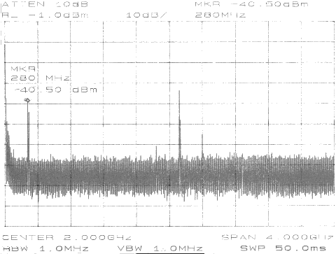

[Fig 8] The output spectrum of the mixer
[Fig 9] The on-wafer tested schematic of RF front-end prototype
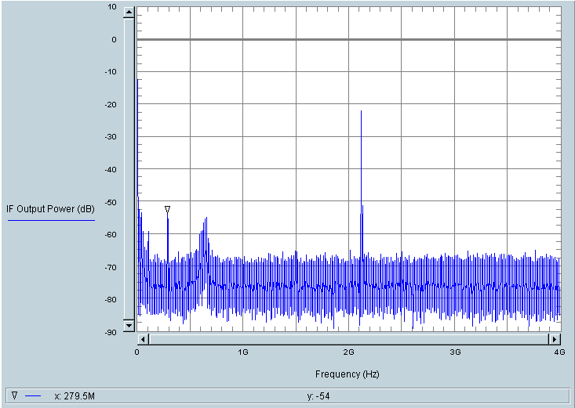

IF output

600MHz low-frequency oscillation

LO
[Fig 10] Output Spetrum of the LNA combined with the mixer
[Fig 11] RF input power (2.4GHz) v.s. conversion gain
[Fig 12] IP3 measurement of the LNA combined with the mixer
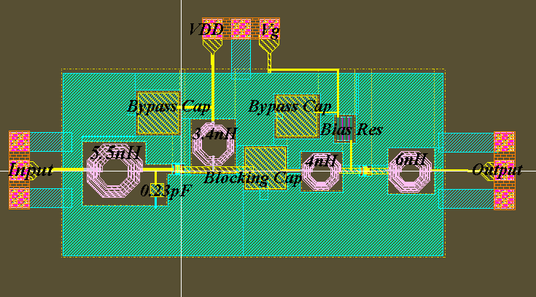
[Fig 13] Layout of double-stage LNA. The die size is 1260μm×2700μm
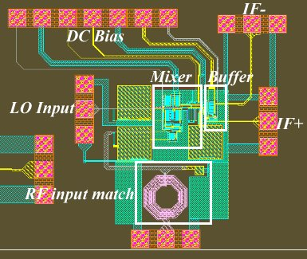
[Fig 14] Layout of the mixer. The die size is 1700μm×1450μm.
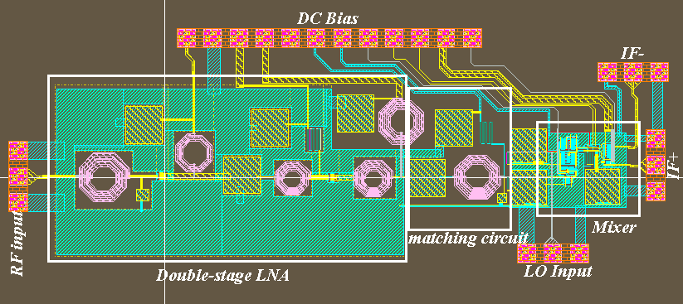
[Fig 15] Layout of LNA combined with the mixer.
The die size is 1370μm×3850μm.

